Survey list

|  |  |  |  |  |  |
| --- | --- | --- | --- | --- | --- |
| marks | Data attribute | form | channel | encode | ref |
| Node (0d) |  | Scatter plot,  Node link,  Nodes mapping to line/map | Color hue | Category |  |
| Shape |
| Color saturation/illumination | Continue value |
| Size | Frequency, volume, importance |
| position |  |
| Line (1d) |  | Straight line,  Straight line with edge binding | Color, line type |  |  |
| Width, opacity |
| Target& source |
| Curve | Path |
| Spiral line | Distance to the center |
| Area (2d) | Temporal data | Stacked graph |  |  |  |
| Sankey diagram |  |  |  |
|  | Radial diagram |  |  |  |
| Keyword |  | Sentence tree,  Word cloud | text |  |  |
| Color hue |
| Color opacity/saturation |  |
| size |

Glyph, annotation/label, metaphor

**Problem driven vs design driven**

For a mark with several encoding channels, it doesn’t matter which channel we explain first as long as these channels are independent. Usually, authors tend to explain the channel with simply visual encoding first.

Order:

**Stream-based design**

**A Visual Backchannel for Large-Scale Events[1]**

**Stacked graph:**

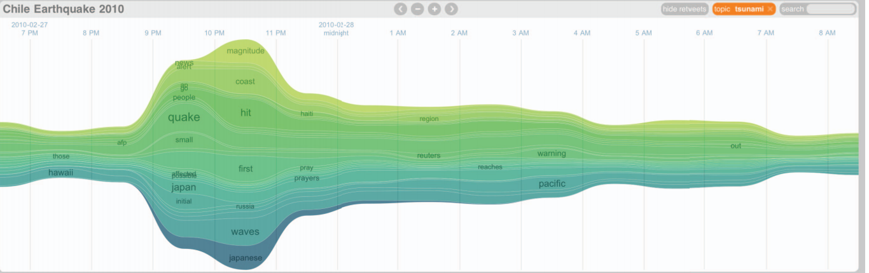

marks: topic stream

Position: x-axis: time, y-position: width: relative frequency,

Ordering: the order of appearance,

Color : newest topics represented by green and the oldest in blue, double encoding with ordering since ordering is only about ranking but not a distribution value.

Shape: defined by cubic Bezier curves for aesthesis issue

Scaling:

Label:

**Nodes mapping to Spiral line:**

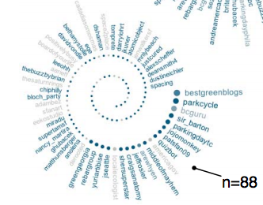

Marks: a user

Shape: none

Size: relative number of tweets

Color saturation: tweets originality

Position on the invisible spiral line: most active user—the outer end

**Text flow[2]**

**Stacked graph with merging and splitting:**

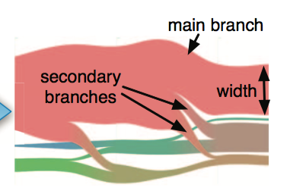

marks: topic

y-axis: height of flow, number of documents of this topic at this time point

shape:

Like a river flow in the real world, the topic flow can be either split into several branches when the corresponding topic splits, or merged with several other branches into one flow when their corresponding topics merge into one topic.

After splitting (or merging), the branch with the content that is most similar to the topic before splitting (or after merging) becomes the main branch

Color hue:

The color of the merged topic flow is the blending of the colors of the corresponding branches

**Glyph-point:**

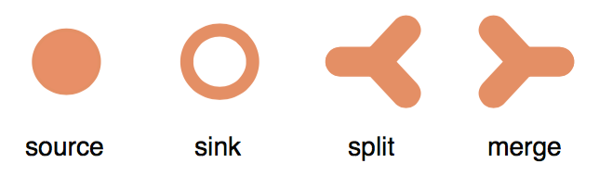

Marks: event of corresponding topic flow

Shape: intuitive meaning

Position: x-position—time point; y-position—topic it belongs

Size: the importance of its corresponding event

**Polyline:**

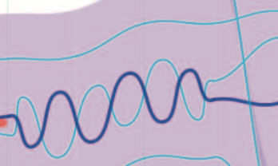

Encode: keyword and;

Source/target: start/end time point;

Width: thick: the primary keyword; thin: other non-primary keywords

Wave Shape: wave effect., co-occurrence interactions

Wave bundle: length of the wave bundle represents the period length of the co-occurrence.

Wave amplitude: bigger the weaving amplitude, the more the corresponding weaving keywords appear at that time point

**Tag cloud:**

**Timeline view:**

**Opinion flow[3]**

In some papers, the encoding scheme is mixed up

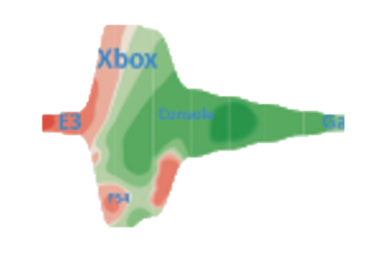

**Sankey diagram:**

**Strip:**

Encode: a topic;

Width: the amount of users attention

Position: x-position time variance,

y-position: layout algorithm, symmetric and reduce the number of crossing lines

**transition line:**

encodes:users attention transfer

source/target: attention transition from topic A to topic B from time t to t + 1

width: the attention transition of all users between topics from time t to t + 1

**Density map:**

Encode: the diffusion of opinions among users

Color hue: red and green visually encode negative and positive opinions, respectively.

Color saturation: the reducing of the saturation give the diffusion effect and indicate the diffusion direction

Kernel placement: time, topic

Kernel scale: scaled by the total number of the users influenced by it

Kernel orientation: kernel orientated according to the average of the directions to influenced users

**Rose river:** **How Hierarchical Topics Evolve in Large Text Corpora [4]**

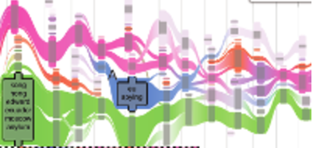

**Vertical bar:**

Encode: a topic, a node in a hierarch topic tree (one visualization to another visualization)

Position: x-position: time point,

x-offset: node depth in the topic tree at this time point

height: number of documents this topic contains

height of inside dark region: proportion of documents that are mapped to the documents both in its previous and next topic trees

**Transition line:**

Encode: the document pairs between 2 topic

Source/target: 2 topics.

Width: the number of document pairs between 2 topics

Color hue: a unique topic

Color saturation: the similarity with the focused topic

**Flux flow [5]**

**Glyph:**

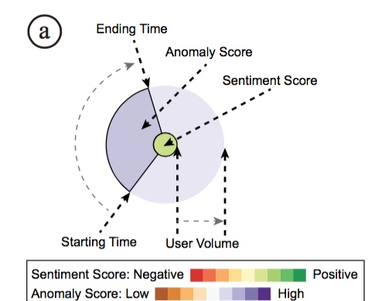

Color of inner circle: sentiment score

Color of outer circle: abnormal score

Radius of out circle: number of users

Widget: Clock metaphor🡪 duration of retweet thread

**Circle volume view**

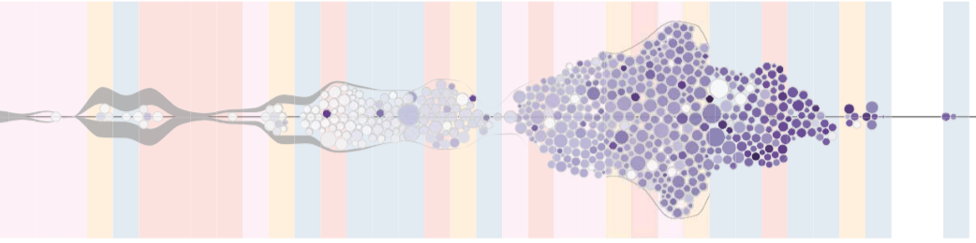

**Circle:**

Encode: an abnormal participant

Size: number of followers

Color: abnormal score

Position: time, pack without overlap

**Volume:**

Encode: normal participants

Width: number of total participants at this time point

**Background:**

Color: hidden state

**Evo river [6]**

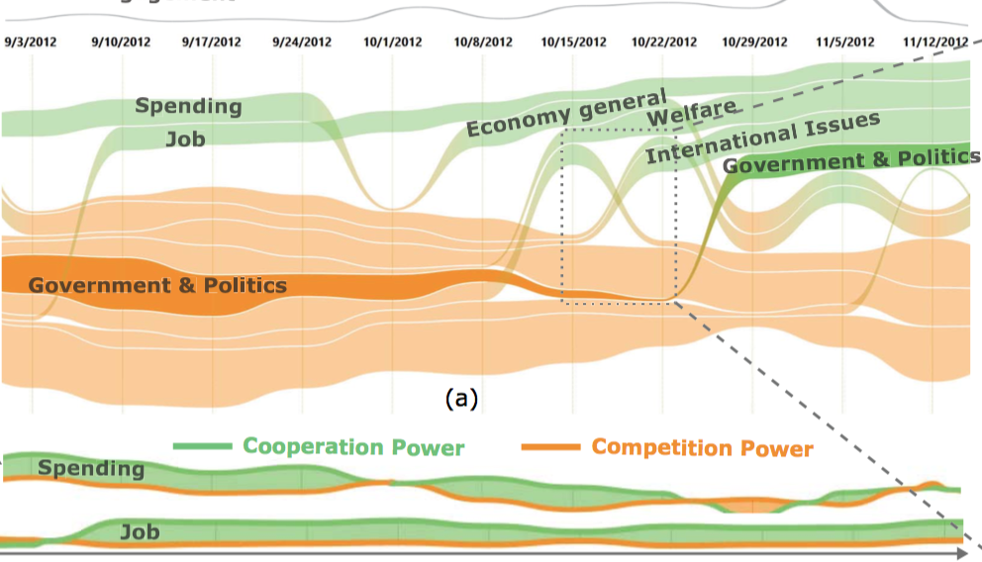

Theme river:

**Strip:**

Encodes: a topic;

Position:

y-position: coopetition power. E.g: top, positive power; bottom: negative power;

stacked order: ??

**thread:**

encode: topic leader group

type: continues: solid line, contribute to the coopetition power of this topic;

transition: dotted line, divert their attention from one topic to another

thickness: degree of the contribution

dotted density: the strength of transition

**Transition line:**

a topic from negative power to positon power. Vice versa

**interaction:**

similarity between topics;

word cloud at a time point of a topic;

**Topic competition[7]**

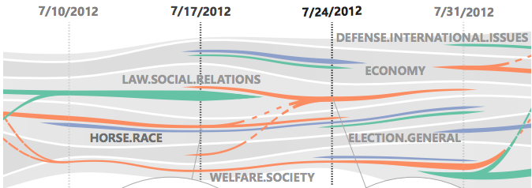

**Layer:**

Encode: a topic

Height: competitiveness of a topic

Accumulated height: over all intensiveness of competition

Color intensity: percentage of public engagement

**Segment line:**

Encode: a opinion leader group

Position: at time t, on a layer if it draw public attention to this topic;

Width: competitiveness contributed to this topic;

Color: categorical color for different opinion group

**Transition line:**

Encode: topic transition;

Source/target: public attention transfer from one topic to another;

Intensity: the strength of topic transition

**Theme delta: [8]**

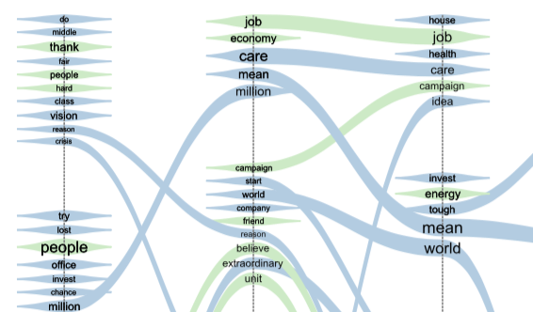

**Vertical line:**

Enconde: time stamp

x-position: time

thickness: relative extent of each time segment;

**segment line:**

color: free

thickness: weight of each keyword

position:

locally, cluster for the same topic

globally, layout algorithm to reduce crossing

label: keyword

**transition line:**

shape: spline

**profiling of musicians[9]:**

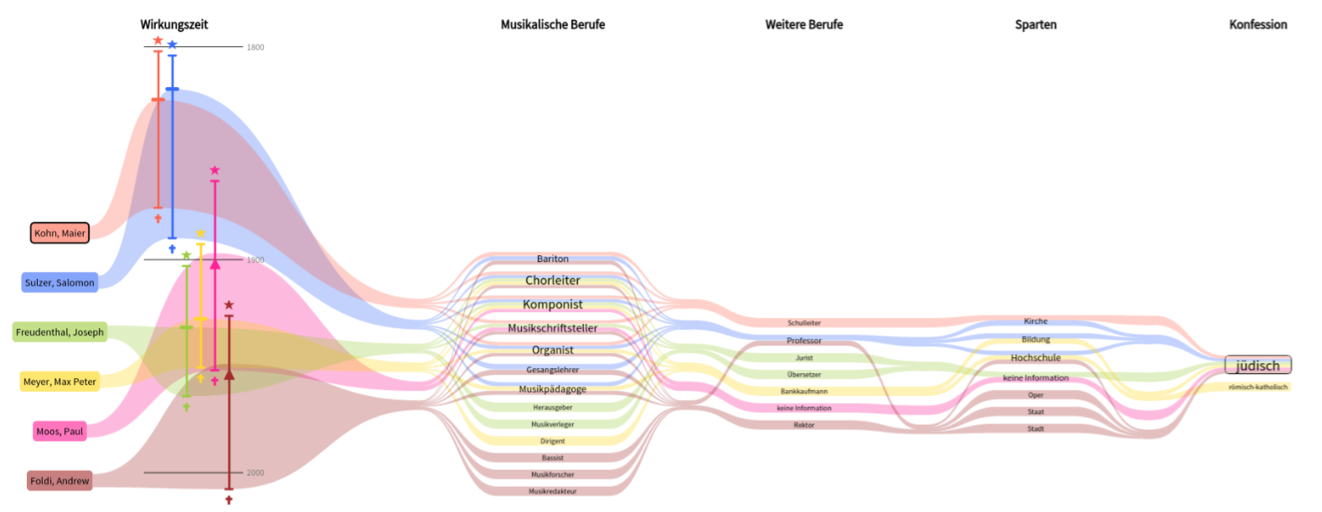

**legend:**

position:

leftmost;

y-position: top the selected musician, then musicians with decreasing similarity with the top one;

background-color: category color for each musician

**vertical line with symbol:**

encode: life time of a musician

source/target: birth/death time;

symbol I: birth/first mentioned/death;

symbol II: exactly at/around/before/after a time point;

color: unique categorical color for each musician

**column:**

encode: division

x-position: different division

**segment line**

encode: attribute of a musician in a division

position: x-positon: the division it belongs

y-position: lay-out order: the attributes of m are listed first in alphabetical order. By descending similarity, further attributes of the deter- mined similar musicians are listed

font size: attribute occurrence

**transition line:**

encode: nothing

connect all the attributes that belongs to the same musician

color: unique categorical color of this musician

width: in life time column, corresponding to the life period;

**topic stream[10]:**

rose river[4] + sentiment animation

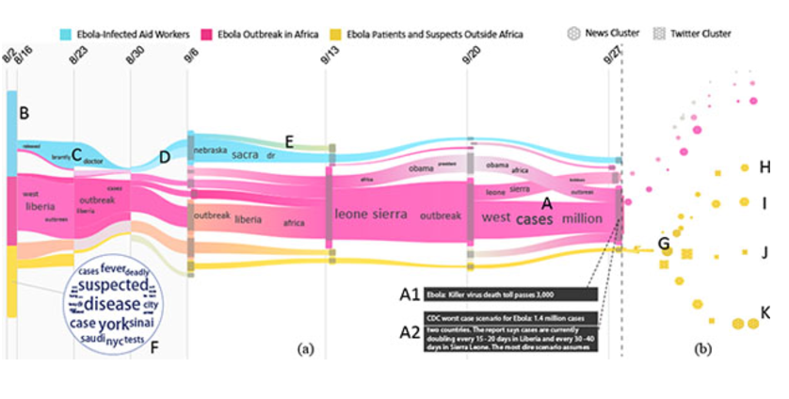

**cite River [11]:**

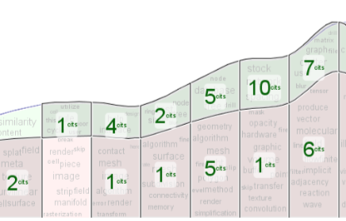

it supposes stream graph is universally recognized, thus need no further explanation

**summarization:**

1. People always called same thing with different name:

theme river=stacked graph=stream graph=enhancement of Sankey diagram;

strip=stream;

thread=line=

1. Basic element:

x-axis: Timeline in most cases, columns for attributes;

height:

segment strip;

transition strip:

marks over strip:

1. Ways of improving stream graph:
2. Mapping other encodes over strip:

Most common, label

Weiwei’s paper, thread for primary and non-primary keyword, glyph for the critical events

Panpan’s paper, thread for opinion leader group

Zhaojian’s paper, nodes for abnormal users

Shixia’s paper, density map over theme river;

1. Change the shape/encoding meaning;

Musician profiling: x-axis from timeline to attributes

Coopetition: height: different topic🡪positive/negative coopetition power;

1. Add more marks/encodings:

Shixia’s paper: add vertical bar to replace segment line;

Evo river: arcs to represent the similarity between topics;

1. An effective narrative template should be:

???

[1] M. Dörk, D. Gruen, C. Williamson, and S. Carpendale, “A Visual Backchannel for Large-Scale Events,” *IEEE Trans. Vis. Comput. Graph.*, vol. 16, no. 6, pp. 1129–1138, Nov. 2010.

[2] W. Cui *et al.*, “TextFlow: Towards Better Understanding of Evolving Topics in Text,” *IEEE Trans. Vis. Comput. Graph.*, vol. 17, no. 12, pp. 2412–2421, Dec. 2011.

[3] Y. Wu, S. Liu, K. Yan, M. Liu, and F. Wu, “OpinionFlow: Visual Analysis of Opinion Diffusion on Social Media,” *IEEE Trans. Vis. Comput. Graph.*, vol. 20, no. 12, pp. 1763–1772, Dec. 2014.

[4] W. Cui, S. Liu, Z. Wu, and H. Wei, “How Hierarchical Topics Evolve in Large Text Corpora,” *IEEE Trans. Vis. Comput. Graph.*, vol. 20, no. 12, pp. 2281–2290, Dec. 2014.

[5] J. Zhao, N. Cao, Z. Wen, Y. Song, Y. R. Lin, and C. Collins, “FluxFlow: Visual Analysis of Anomalous Information Spreading on Social Media,” *IEEE Trans. Vis. Comput. Graph.*, vol. 20, no. 12, pp. 1773–1782, Dec. 2014.

[6] G. Sun, Y. Wu, S. Liu, T. Q. Peng, J. J. H. Zhu, and R. Liang, “EvoRiver: Visual Analysis of Topic Coopetition on Social Media,” *IEEE Trans. Vis. Comput. Graph.*, vol. 20, no. 12, pp. 1753–1762, Dec. 2014.

[7] P. Xu *et al.*, “Visual Analysis of Topic Competition on Social Media,” *IEEE Trans. Vis. Comput. Graph.*, vol. 19, no. 12, pp. 2012–2021, Dec. 2013.

[8] S. Gad *et al.*, “ThemeDelta: Dynamic Segmentations over Temporal Topic Models,” *IEEE Trans. Vis. Comput. Graph.*, vol. 21, no. 5, pp. 672–685, May 2015.

[9] S. Jänicke, J. Focht, and G. Scheuermann, “Interactive Visual Profiling of Musicians,” *IEEE Trans. Vis. Comput. Graph.*, vol. 22, no. 1, pp. 200–209, Jan. 2016.

[10] S. Liu, J. Yin, X. Wang, W. Cui, K. Cao, and J. Pei, “Online Visual Analytics of Text Streams,” *IEEE Trans. Vis. Comput. Graph.*, vol. 22, no. 11, pp. 2451–2466, Nov. 2016.

[11] F. Heimerl, Q. Han, S. Koch, and T. Ertl, “CiteRivers: Visual Analytics of Citation Patterns,” *IEEE Trans. Vis. Comput. Graph.*, vol. 22, no. 1, pp. 190–199, Jan. 2016.